Purchasing procedure at University of Cambridge, Faculty of Divinity
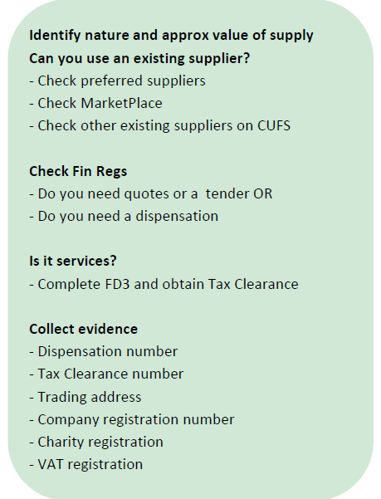
- Modern Slavery Act statement signed (see the form below)
- Quotation addressed to:
University of Cambridge, Faculty of Divinity, West Road, Cambridge, CB3 9BS
On headed paper with the supplier’s details:
- Registered name,
- Address,
- Number,
- Charity number,
- VAT registration number,
- Contact details (www, email, phone number),
- Service/goods description,
- Price,
- VAT rate

- Signed service agreement
- Invoice
Schedule 1 - Competition Procedures
If the contract’s total value equals or exceeds £5,000, obtain three quotations from various potential suppliers. If this is not possible, explain the circumstances in a dispensation from normal competition requirements using an online form, and when granted, forward the notification to the finance team.
https://www.procurement.admin.cam.ac.uk/information/dispensation

or download from website.
Include the supplier’s bank details, full name, full address, contact details (email) and service details. Indicate any extra costs (travel/material) and then they can be included on the invoice together with the fee.
Or download from the Procurement website.
To obtain Tax Clearance Number for a service provider, fill the form:
https://www.finance.admin.cam.ac.uk/fd3-employment-status-form

Obligatory elements to include on invoices from suppliers:
- Addressed to:
University of Cambridge, Faculty of Divinity, West Road, Cambridge, CB3 9BS
- Supplier’s registered name
- Supplier’s registered number
- Supplier’s full address
- Supplier’s VAT registration number
- Supplier’s bank details
- Invoice unique number
- Invoice date
- Purchase Order number (issued by Faculty of Music, to issue a PO firstly the supplier must be set up)
- Description of the service/goods provided
- Net cost
- Number of items/services
- Total net amount
- VAT rate
- VAT amount for each rate
- Gross amount

Simple invoice template (or see below):

VAT
CU’s VAT registration number is GB 823 8476 09.
Purchasing goods from outside the EC - When buying goods from countries outside the EC VAT will not be charged by the supplier. However, both VAT and duty will be applied when the item comes through Customs at the port of entry, if applicable, and is usually charged via your import agent.
Purchasing services from outside the UK - The overseas supplier should not charge VAT on its invoice. This is not as beneficial as it might seem because the University is required by law to charge itself VAT at the UK standard rate of 20% (if the services would have been subject to standard rate VAT if purchased in the UK). This puts the University in the same position as if we had received the supply from a UK supplier rather than from one outside the UK.
Provide the University's VAT number (GB 823 8476 09) to demonstrate you are a business customer or the supplier may charge you VAT at the rate applicable in their country.

Invoice template
Supplier’s full name
Supplier’s address
Email
Phone

University of Cambridge
Faculty of Divinity
West Road, Cambridge, CB3 9BS

PO number:
Invoice date: YYYY-MM-DD
Invoice number: 1

Service: [service description plus any extra costs – as per contract]

Net Price: GBP
VAT rate:
Total to pay: GBP

Bank details:
IBAN:
BIC:
BANK
Sort code & bank account number:
Bank account name:

