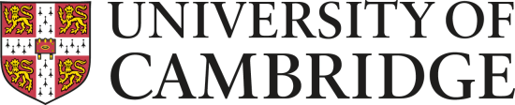

Faculty of Divinity
Induction for New Students
Wednesday 4 October 2017

Session 1 All students Runcie

9:15-9:30 Welcome Prof McFarland

Session 2A TRIPOS STUDENTS RUNCIE

9:30-10:15 Introduction to the major areas of study

Religious Studies Dr Barua
Philosophy of Religion Prof Coakley
New Testament Dr Linebaugh
Old Testament Dr Aitken
Christian Theology Prof. McFarland
History of Christianity Dr Lunn-Rockliffe

Session 2B BTh STUDENTS ROOM 3

9:30-10:15 Being a BTh student Dr John
in the Divinity Faculty and others

Session 3 ALL STUDENTS Runcie

10:15-10:45 Studying at Cambridge Dr Weiss



10:45–11:05 Coffee all students Foyer &
Common Room


Session 4 Runcie

11:10 Health and Safety Mr Brittain

11:15 Computing facilities Mr Goode

11:30 Learning languages Dr Aitken

12:00 Language Classes Runcie

Greek (with test) Dr McLarty
Hebrew (Room 2) Dr Phillips
Arabic (Room 4) Dr Street



Session 5 Runcie

2:30 Library Facilities Dr Gresser
and Mr Patmore

Session 6a Runcie

3:30 Second Greek Class Dr McLarty
4:00 Sanskrit Introduction (FAMES, 313) Dr Vergiani

Session 6B Adv. Diploma students Lightfoot

3:00 Introduction to the Diploma Course Dr Weiss



